Proposed Title :-

**Health Buddy : A Health Care Website With AI Chatbot**

**MENTOR**: Prof.Akash Goel

**MEMBERS**:

SATYAM Roll No: 2000290129005

SHUBHAM SHARMA Roll No: 2000290129006

Field of Invention : -

**FULL STACK + MACHINE LEARNING**

Background(Reason to Work):-

* Artificial intelligence (AI) is now a days increasingly being used in healthcare. Here, AI-based chatbot systems can act as automated chat bot sysytem, capable of abet health, providing education, and potentially prompting behaviour change.
* Healthcare is very important to lead a good life. However, it is very difficult to obtain the consultation with the doctor for every health problem.
* The idea is to create a medical chatbot with Website using ML that can provide basic details about the disease before consulting a doctor.
* This will help to reduce healthcare costs and improve accessibility to medical knowledge through medical chatbot.

Objective:-

* In This website we are giving Detailed information about the hospital and its operation.
* This website is designed in an interactive manner and is able to give the users the knowledge of the expertise , experience and hospitality of the hospital.
* We are adding a Chatbot in the website using ML that provide basic detail about the disease before consulting a doctor .
* We are using Machine Learning concept it will be implemented in Python Programming language.
* In our proposed system the user can chat with the bot regarding the query through text. The system uses an expert system to answer the queries.
* The data of the chatbot stored in the database in the form of pattern-template. Bot will provide analgesics and food suggestions that means which food you have to take based on the disease.
* Other modules will be added it to with time.

Figures/Model/Flowchart:-

Flow charts: -

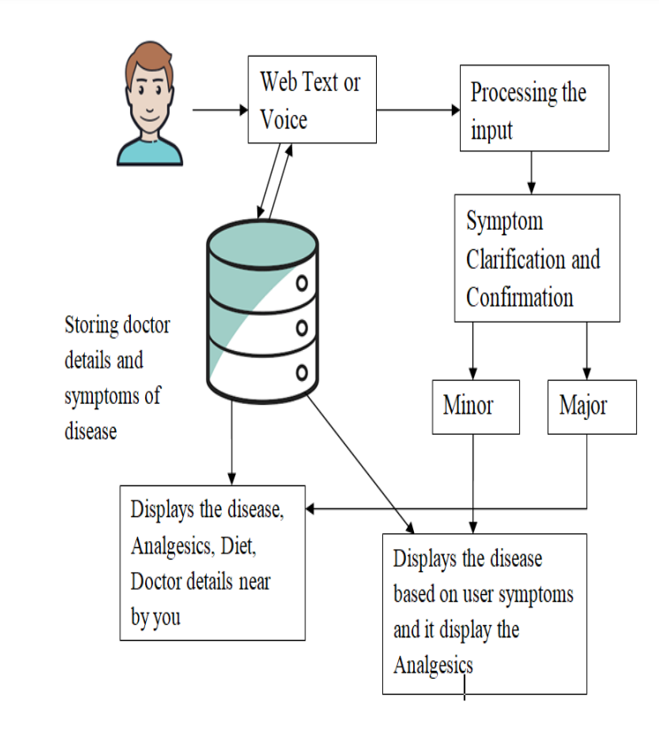

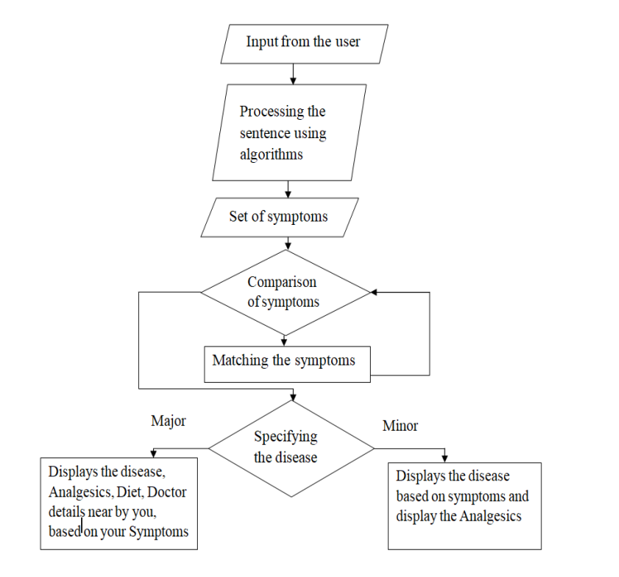

Claims(Novel/Innovative ideas):-

* It is very difficult to obtain the consultation with the doctor for every health problem.
* The idea is to create a medical chatbot with Website using ML that can provide basic details about the disease before consulting a doctor.
* This will help to reduce healthcare costs and improve accessibility to medical knowledge through medical chatbot.

Apparatus / Technology Used:-

* PYTHON
* HTML
* CSS
* JAVASCRIPT
* MYSQL
* There are Various Supervised Learning Algorithm are used.

1. N-gram Algorithm

2. TF-IDF(Term frequency-inverse data frequency)

3. Cosine similarity algorithm

Abstract:-

Healthcare is very important to lead a good life. However, it is very difficult to obtain the consultation with the doctor for every health problem. The idea is to create a medical chatbot using Artificial Intelligence that can diagnose the disease and provide basic details about the disease before consulting a doctor. This will help to reduce healthcare costs and improve accessibility to medical knowledge through medical chatbot. The chatbots are computer programs that use natural language to interact with users. The chatbot stores the data in the database to identify the sentence keywords and to make a query decision and answer the question. Ranking and sentence similarity calculation is performed using n-gram, TFIDF and cosine similarity. The score will be obtained for each sentence from the given input sentence and more similar sentences will be obtained for the query given. The third party, the expert program, handles the question presented to the bot that is not understood or is not present in the database.

End users:-

Any Person who wants to get the Consultant from the Doctors . They can use the ChatBt and they can save their Time and Money . The Health care Chatbot will be preferable for any small Health based issue .

Advantages: -

* Reduced costs, improved efficiency.
* Answering questions.
* Improving diagnostic accuracy.
* Monitoring patients.
* Chatbots as healthcare companions.
* Smoothing insurance issues.
* Improving patient satisfaction.
* Greater efficiency.

Summary / Conclusion:-

A Chatbot is a great tool for conversation. Here the

application is developed to provide quality of answers in a short period of time. It removes the burden from the answer provider by directly delivering the answer to the user using an expert system. The project is developed for the user to save the user their time in consulting the doctors or experts for the healthcare solution. Here we developed the application using the N-gram, TF-IDF for extracting the keyword from the user query.